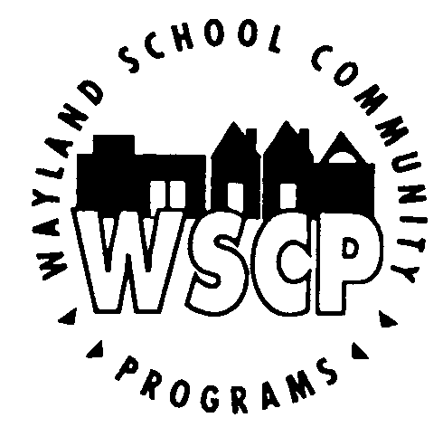 Private Music Lesson Registration Form
47 Loker Street
Wayland, MA, 01778
(508) 655-3103
Spring 2016

This is an OPTIONAL opportunity for orchestra members Grades 3-12, band members Grades 4-12, and chorus members Grades 6-12 enrolled in the Wayland Public School music program. Private lessons are NOT required but are encouraged by the Wayland Fine Arts Department.

Please complete and return this application with your first semester payment. Upon receipt, Bernadette Vanaria will coordinate a lesson time between the teacher and student. Payment will not be processed until the WSCP is notified that a lesson schedule has been arranged.

Student Name______________________________________________________

2015-16 Student Grade___________School________________________________

Parent/Guardian Name_______________________________________________

Address__________________________________________________________

Home Phone______________________ Cell Phone_________________________

Email:(please print clearly)_____________________________________________

Instrument or voice part__________________ Preferred Teacher________________

Preferred Location For Lessons (circle) Claypit Hill / Happy Hollow / Loker / WMS / WHS

Available Days For Lessons: M T W Th F

Available Time Frame:__________________________________________

Check Preferred Length | Lesson  Length | Cost  Per  Semester | Semester  Registration  Fee | Total  Payment  Due
 | 30 minutes | $550 | $50 | $600.00
 | 45 minutes | $817.50 | $50 | $867.50
 | 60 minutes | $1065 | $50 | $1115.00

Send application & check for the Total Payment Due payable to:

WSCP Private Lesson Program
Claypit Hill School 40 Adams Lane Wayland, MA 01778
ATTN: Ms. Bernadette Vanaria, Program Coordinator

Please write “Private Music Lessons” in the Memo Blank

