Wayland High School
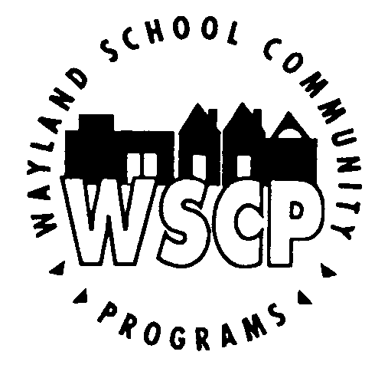
SUMMER JOURNALISM CAMP
July 2-6, 2018

PROGRAM DESCRIPTION

Wayland High School junior Nathan Zhao will be offering a free, 4-day, journalism and public speaking course for Wayland Public School students entering grades 8 and 9, July 2-6 (no class on July 4), at Wayland High School.

Nathan will be a senior in the fall and is the recipient of a Scholastic Art and Writing Awards Gold Medal, the winner of the 2018 National Civic Expression Award, and the winner of the 2017 Wayland Veterans Memorial Freedom Prize. He will also be representing Massachusetts at the 2018 Al Neuharth Free Spirit Journalism Conference in Washington, D.C. Additionally, Nathan is the Editor-in-Chief of Wayland Student Press Network (WSPN), Wayland High School's student-run, award-winning newspaper (most recently winning the 2018 NSPA’s Pacemaker Award). He is also captain of the Speech/Debate and Model United Nations teams at WHS.

The camp will be co-taught by Kevin Wang, a rising junior at WHS and the current News Section Editor of WSPN. Kevin also co-championed the 2018 Lakeland Debate Invitational and received a mark of “Excellent” in News Writing from the Journalism Educator’s Association. The camp's guest speaker will be Luke Xu, a member of WHS' Class of 2016 and a rising junior at Harvard College. Xu formerly served as Editor in Chief of WHS' Yearbook and founder of WHS' Speech and Debate Team.

Students will receive detailed, thorough critiques on their writing. Students of all skill levels are encouraged to apply, and critiques will be tailored to a student's writing level. The course is designed to supplement, enhance, and reinforce students' writing skills from English class, while exposing them to new forms of writing. The course will focus on two topic areas: journalism and public speaking. All students interested in Speech and Debate or WSPN in High School are encouraged to enroll for the class, but all registrations are welcome. At least two days of the course will be focused on Public Speaking, and students will be able to practice this vital lifelong skill in front of a group of learners. No prior experience with journalism or public speaking is required.

Registration will be limited to 12 students to ensure a small group learning environment.

Registrations will be accepted on a first-come, first-serve basis. Please email the registration and/or questions directly to Nathan Zhao at nathan_zhao@student.wayland.k12.ma.us.

PROGRAM SCHEDULE

Dates: Monday, Tuesday, Thursday and Friday, July 2-6, 2018
Time: 9:00-11:30am
Location: Wayland High School; room location to be determined
Requirements: Students must be entering Grades 8 or 9 at WPS.

Minimum of 5 and maximum of 12 students will be enrolled.

All registrants must attend all classes; no drop-ins allowed.

Each student must provide a personal laptop computer with Microsoft Word and WiFi functionality, writing implement and a paper notebook.
Student Information SUMMER JOURNALISM CAMP/WAYLAND HIGH SCHOOL

Name: ________
Mailing Address:
Parent E-Mail: _________________________________ _______ Grade in WPS:
_____ The student is interested in Speech and Debate/WHS' Speech and Debate Team

_____ The student is interested in Journalism/WSPN

Email registrations to: nathan_zhao@student.wayland.k12.ma.us by Fri., June 29, 2018

EMERGENCY CONTACTS

Emergency Contacts

Name: Phone:
Relationship to student:

Name: Phone:
Relationship to student:

Name: Phone:
Relationship to student:

PERMISSIONS
Please choose the transportation option(s) below that apply:

____ My child will be driven to and/or from WHS to participate in this class.
____ My child has permission to walk to and/or from WHS to attend this class.

AGREEMENT TO POLICIES/LIABILITY WAIVER

My signature on this form indicates agreement to abide by the policies set forth by Nathan Zhao and Wayland School Community Programs for the duration of this class.

I/We release the Wayland School District, Wayland School Community Programs and its representatives of liability in case of injury or accident and agree to allow WHS personnel to obtain medical treatment for the student listed below should it become necessary.

________________________________________________ ____________
Signature of Member Date

________________________________________________ _____________
Signature of Parent/Guardian Date
(required for participants under 18 years of age on start date)

Wayland Public Schools, 41 Cochituate Rd., Wayland, MA 01778

