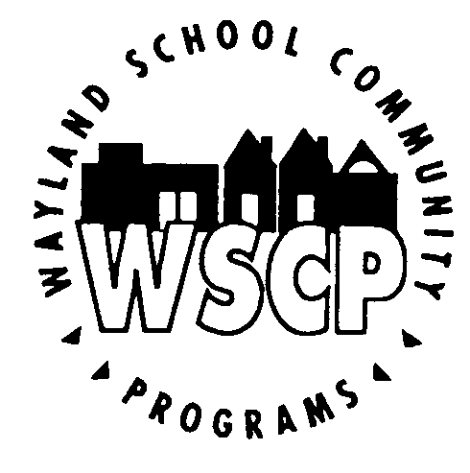
Wayland High School
SUMMER JOURNALISM CAMP
July 8-12, 2019

PROGRAM DESCRIPTION

Wayland High School senior Kevin Wang will be offering a free, 5-day, journalism and public speaking course for Wayland Public School students entering grades 8 and 9, July 8-12, at Wayland High School.

Kevin will be a senior in the fall and the Editor-in-Chief of the Wayland Student Press Network (WSPN), Wayland High School's student-run, award-winning, online newspaper. Kevin has been awarded the mark of Excellence in News Writing by the Journalism Education Association and wrote the No. 3 scholastic Story of the Year. Kevin will also be varsity captain of the Wayland High School Speech & Debate team and attend the Tournament of Champions in Lexington, Kentucky.

Kevin’s three instructors will be rising juniors Atharva Weling, Aiden Zhang, and Randy Wang. Their collective positions and awards include novice captain of the Wayland High School Speech and Debate team, treasurer of the Class of 2021, recipient of the Scholastic Art and Writing Award for Personal Essay/Memoir, and attendee of the Tournament of Champions.

The camp's guest speaker will be Nathan Zhao, the founder and previous administrator of this camp for two years. Nathan will be attending Harvard College this fall. At Wayland High School, he served as an Editor-In-Chief of WSPN as well as a 2-year captain of both the Speech & Debate and Model United Nations teams.

Students will receive detailed, thorough critiques on their writing. Students of all skill levels are encouraged to apply, and critiques will be tailored to a student's writing level. The course is designed to supplement, enhance, and reinforce students' writing skills from English class, while exposing them to new forms of writing. The course will focus on two topic areas: journalism and public speaking. All students interested in Speech and Debate or WSPN in High School are encouraged to enroll for the class, but all registrations are welcome. At least three days of the course will be focused on Public Speaking, and students will be able to practice this vital lifelong skill in front of a group of learners. No prior experience with journalism or public speaking is required.

Registration will be limited to 20 students to ensure a small group learning environment, creating a 5:1 student to instructor ratio that will guarantee an individualized experience.

Registrations will be accepted on a first-come, first-serve basis. Please email the registration and/or questions directly to Kevin Wang at kevin_wang@student.wayland.k12.ma.us.

PROGRAM SCHEDULE

Dates: Monday, Tuesday, Wednesday, Thursday and Friday, July 8-12, 2019
Time: 9 a.m. to 12 p.m.
Location: Wayland High School; room location to be determined
Requirements: Students must be entering Grades 8 or 9 at WPS.

Minimum of 8 and maximum of 20 students will be enrolled.

All registrants must attend all classes; no drop-ins allowed.

STUDENT INFORMATION Summer Journalism Camp 2019 Registration

Name: ______________________________________________________________________________________________________
Mailing Address: _________________________________________________________________________________________
Parent E-Mail: _________________________________ _______ Grade in WPS:
_____ The student is interested in Speech and Debate/WHS' Speech and Debate Team

_____ The student is interested in Journalism/WSPN

Email registrations to: kevin_wang@student.wayland.k12.ma.us by Fri., June 28, 2019

EMERGENCY CONTACTS

Emergency Contacts

Name: _____________________________________________ Phone: _________________________________ Relationship to student: _______________________________________________________________

Name: _____________________________________________ Phone: ________________________________________ Relationship to student: ________________________________________________________________

Name: ___________________________________________ Phone: _________________________________________
Relationship to student: _______________________________________________________________

PERMISSIONS
Please choose the transportation option(s) below that apply:

____ My child will be driven to and/or from WHS to participate in this class.
____ My child has permission to walk to and/or from WHS to attend this class.

AGREEMENT TO POLICIES/LIABILITY WAIVER

My signature on this form indicates agreement to abide by the policies set forth by Kevin Wang and Wayland School Community Programs for the duration of this class.

I/We release the Wayland School District, Wayland School Community Programs and its representatives of liability in case of injury or accident and agree to allow WHS personnel to obtain medical treatment for the student listed below should it become necessary.

_________________________________________________ ____________
Signature of Member Date

_________________________________________________ _____________
Signature of Parent/Guardian Date
(required for participants under 18 years of age on start date)

Wayland Public Schools, 41 Cochituate Rd., Wayland, MA 01778

